- When pasting text directly from a Word (2003) document into one of the taxon description text boxes (e.g. general description) additional line breaks are added to the text. These additional line breaks can be seen only AFTER the taxon description is saved; during the edit stage the text appears fine within the text box.

- If text is pasted as plain text e.g. from notepad, no additional line breaks are added and the text appears justified (and looks a lot neater!)

- For example, in the picture below, the paragraph at the top was pasted directly from Word into the general description box. The paragraph at the bottom was pasted from Word, into Notepad, and then into the general description box (the italics on the species name are therefore lost).
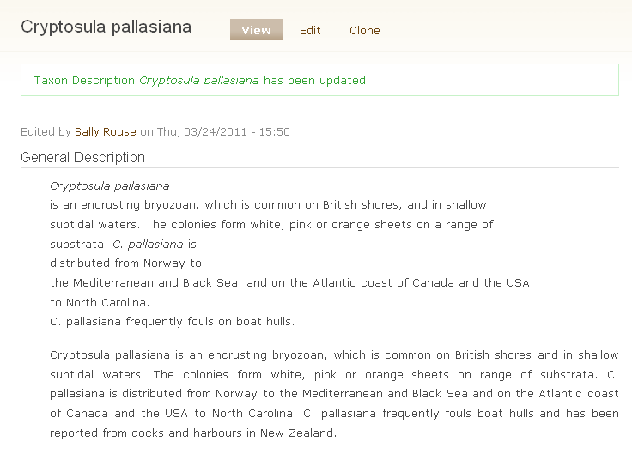
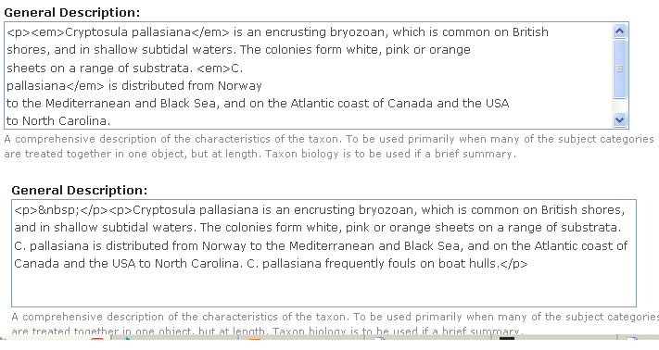
- The HTML code, which is shown briefly after saving a new taxon description, differs depending on whether the text was pasted from Word or Notepad. The paragraph pasted from Notepad has “&nbsp” at the beginning (bottom of picture below), which apparently represents “a non-breaking space”, the paragraph pasted from word does not have this.

